ASSIGNMENT - 6

PROBLEM STATEMENT : Upload a static website on S3.

To upload the website -

STEP 1-Create 3 Static Webpages using HTML .

STEP 2- Click on the S3 button.

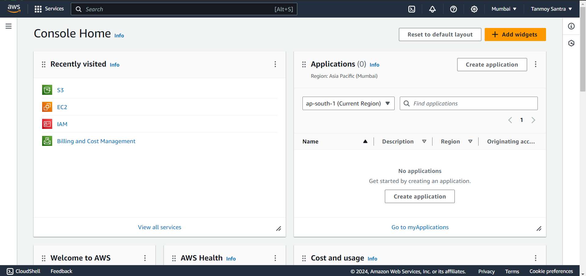

STEP 3- Click on “Create Bucket”.

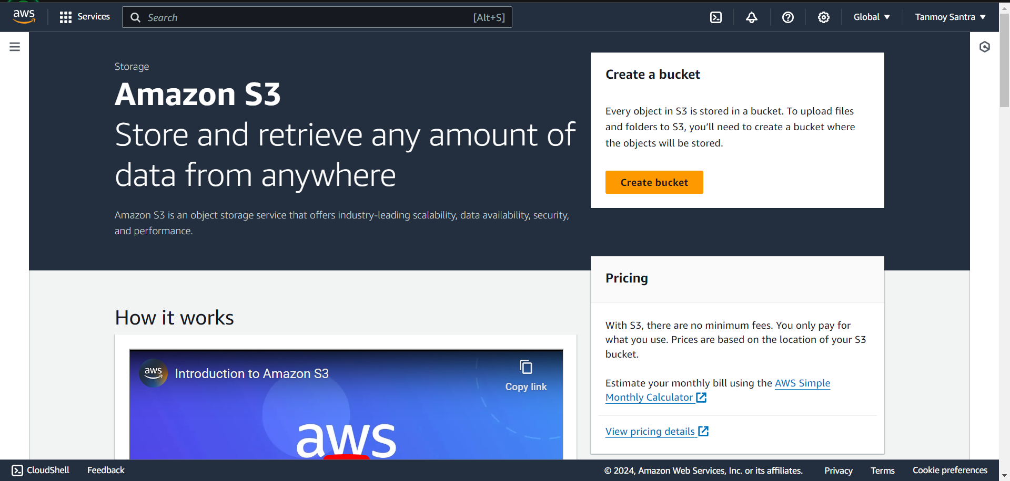

STEP 4- Give name, and Select “ACLs enabled” option under the Object Ownership heading.

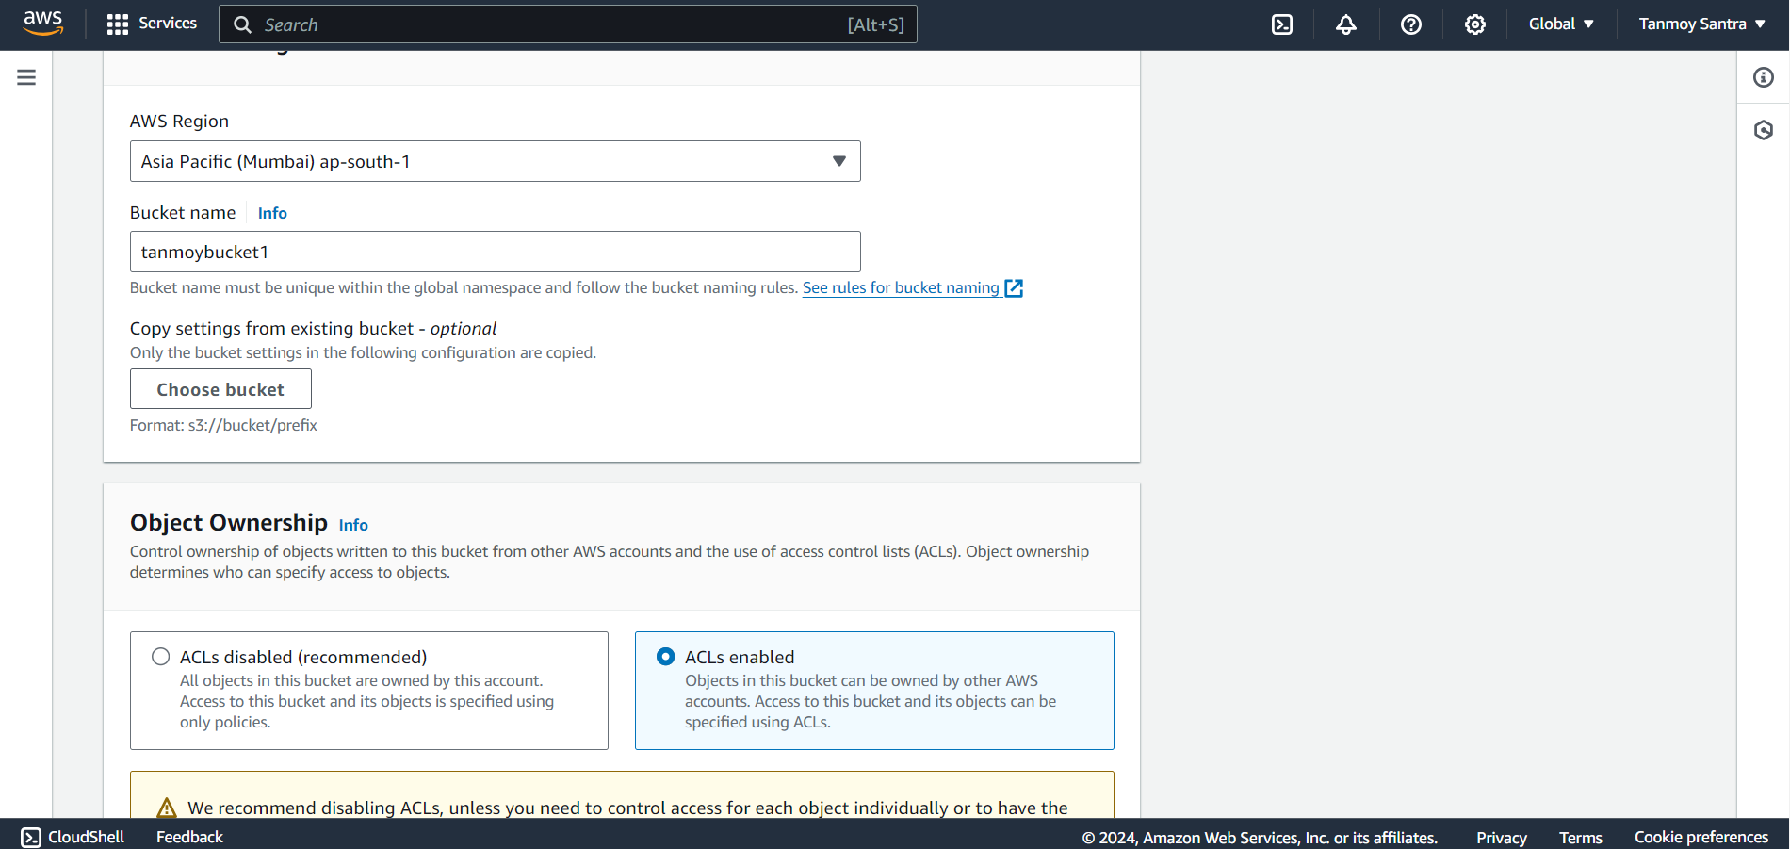

STEP 5-Uncheck Block all public access & click the I acknowledge checkbox.

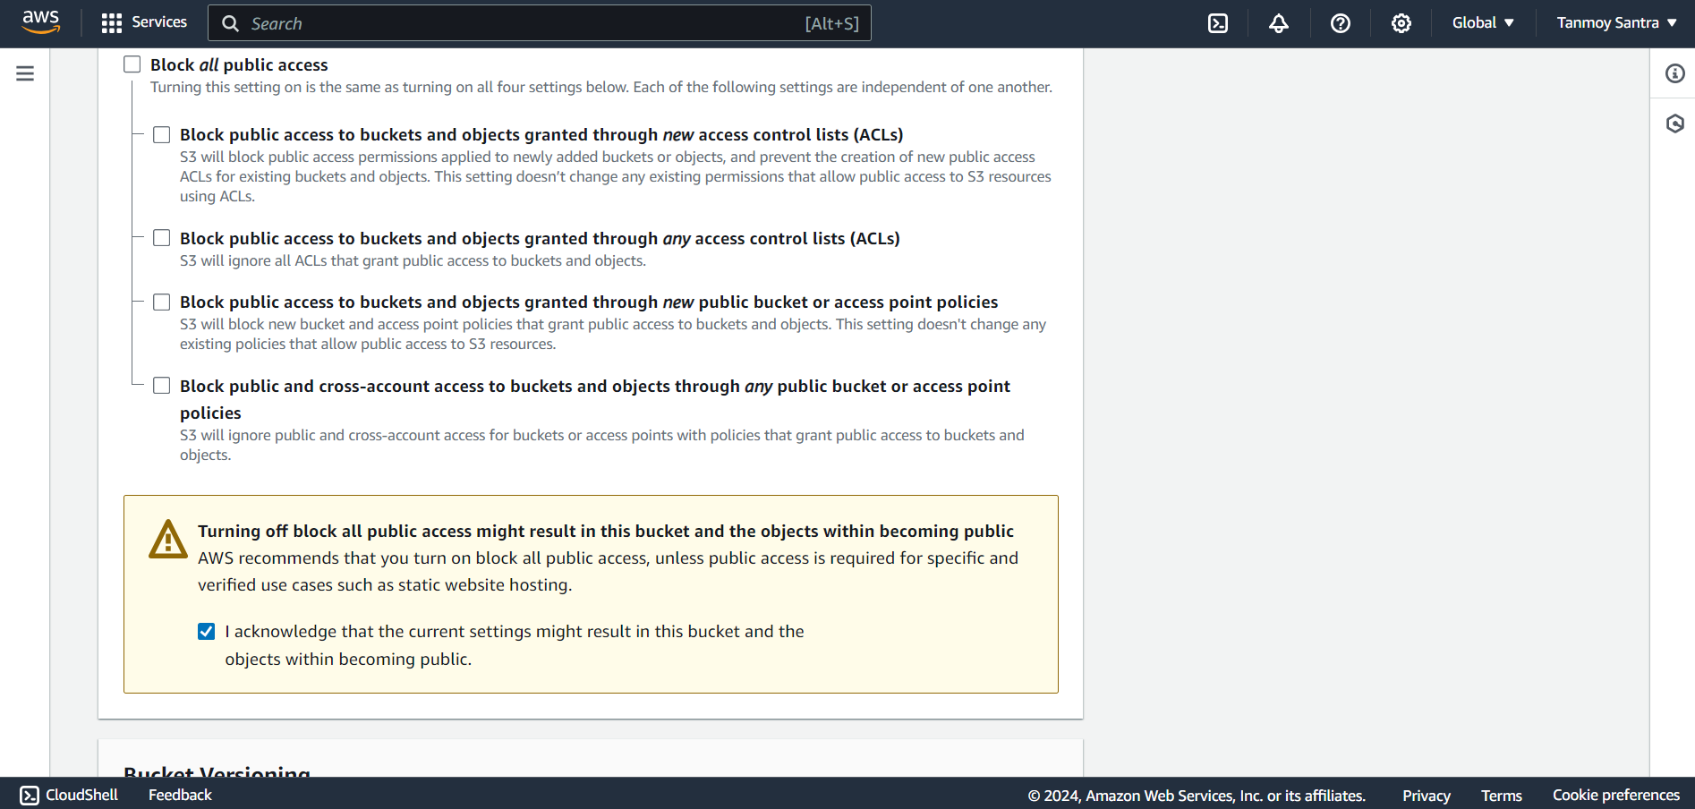

STEP 6- Click on Create Bucket.

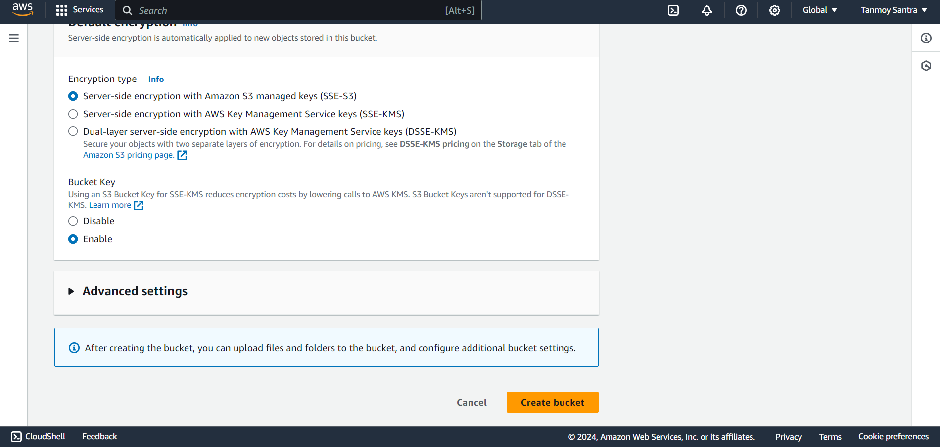

STEP 7- The Bucket is thus created successfully.

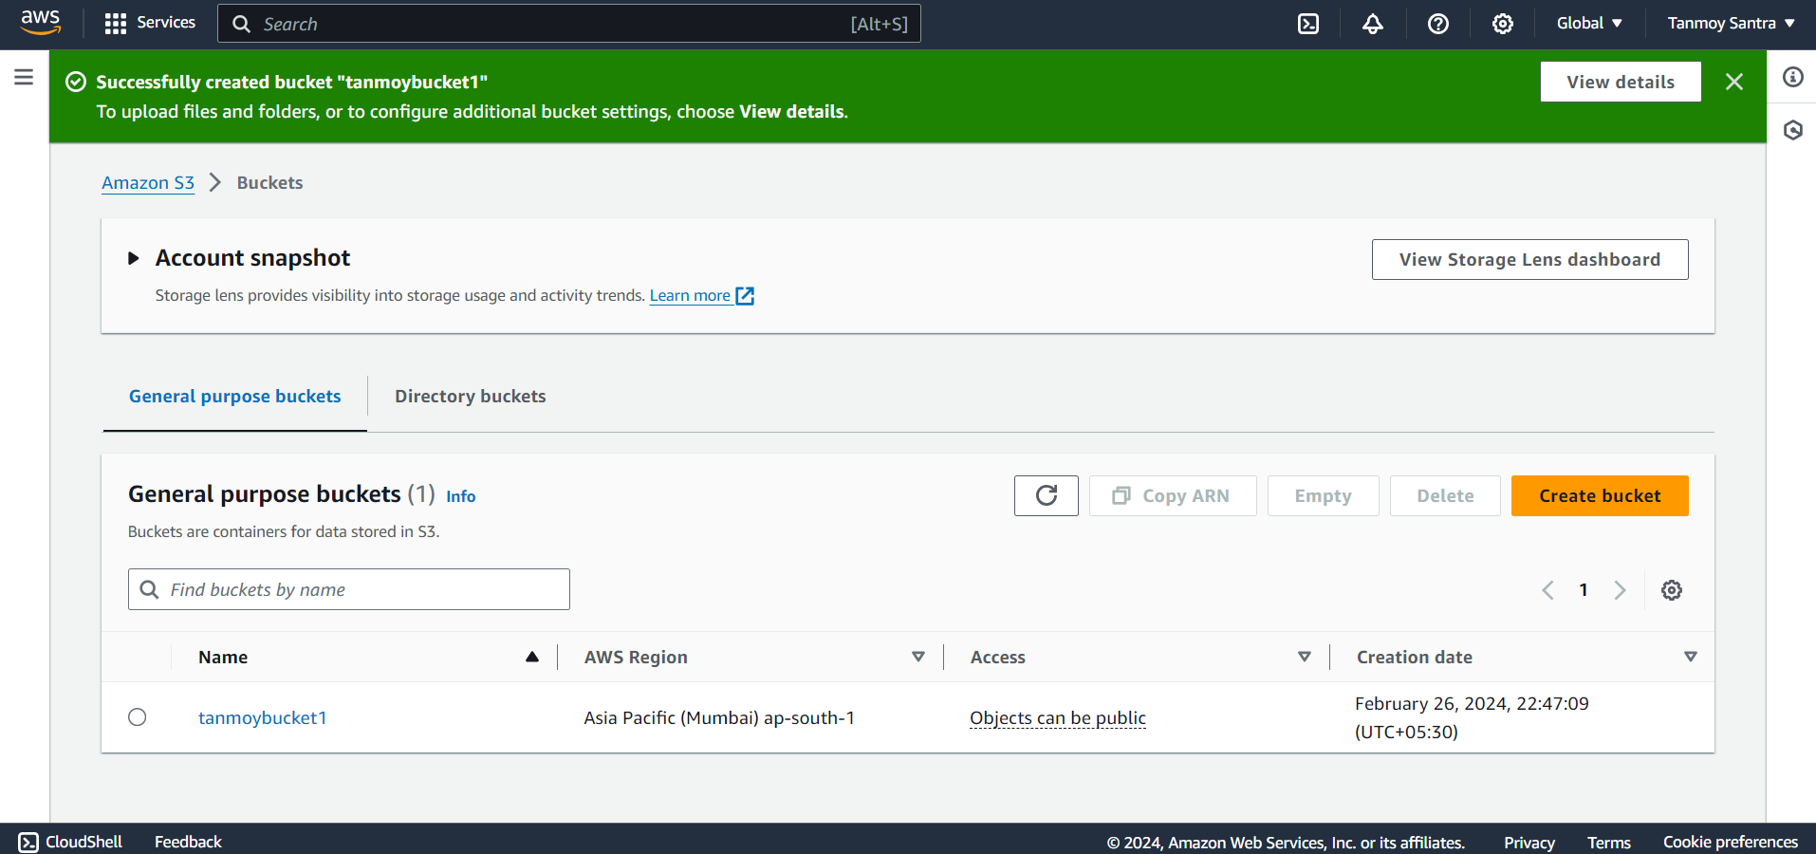

STEP 8- Click on the Upload.

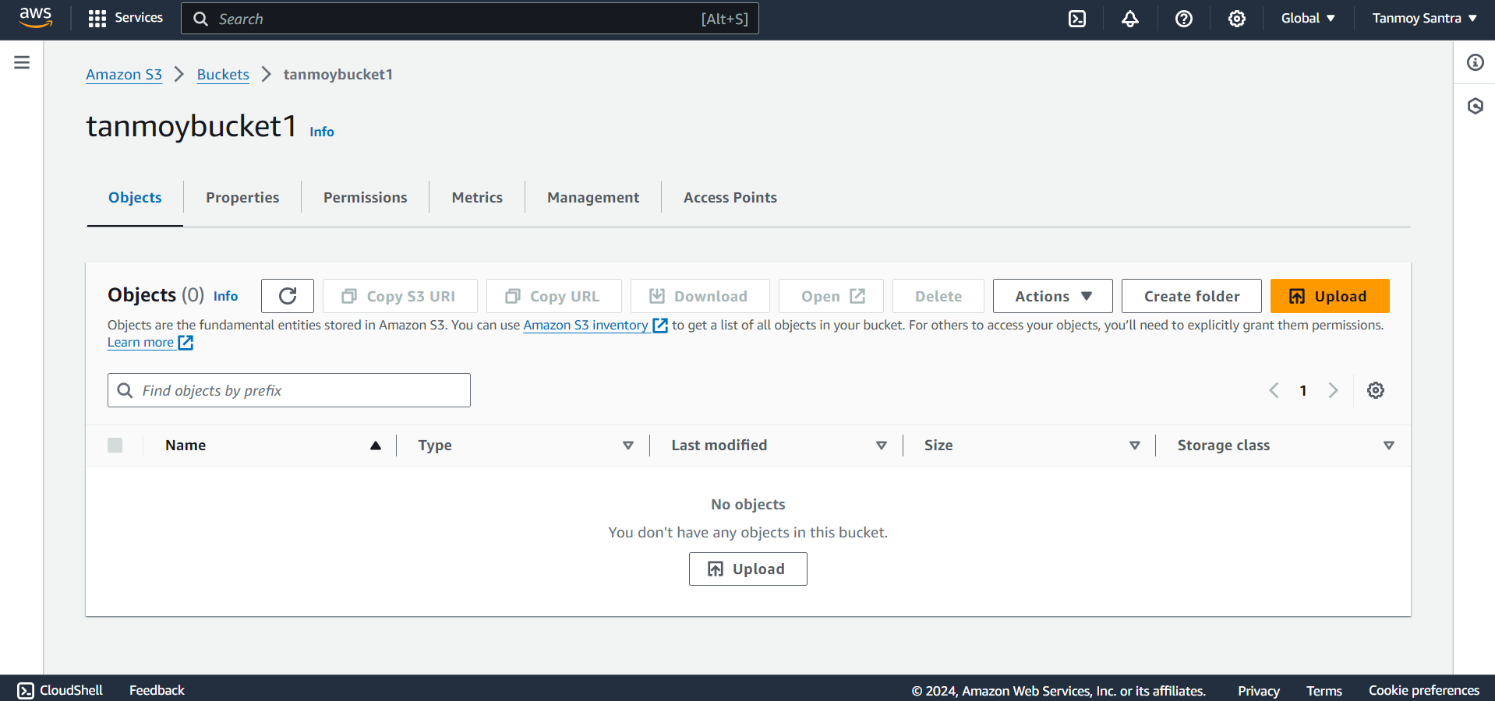

STEP 9- Click on Add file and add the html files.

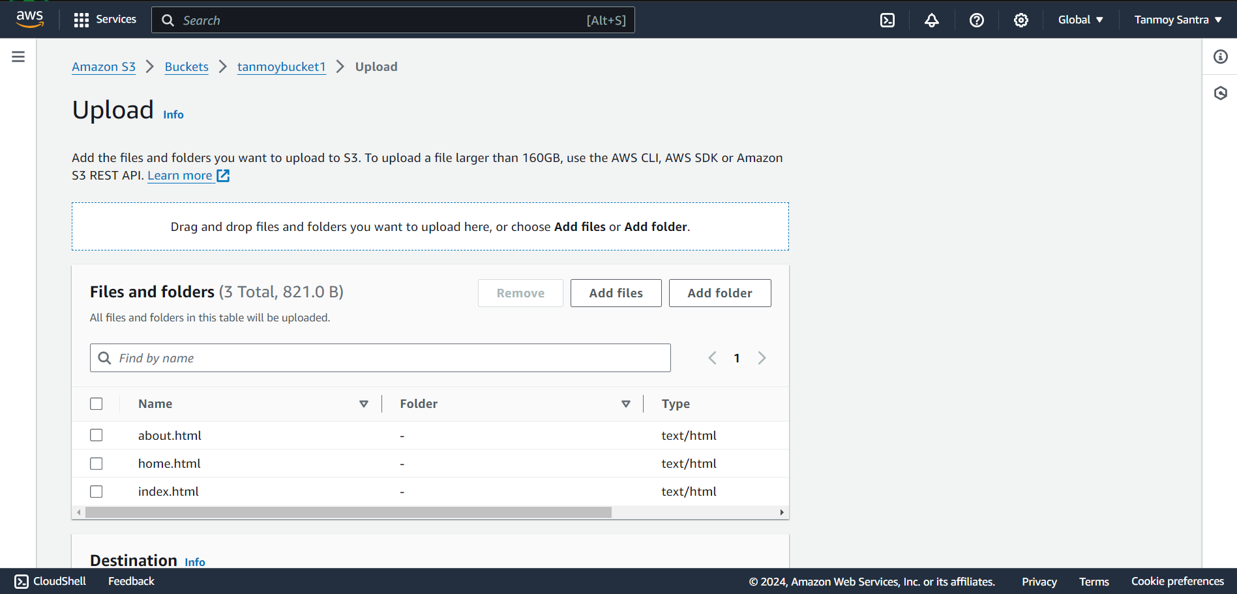

STEP 10- Select Granting Public Read Access option. Click the “I understand” then click Upload.

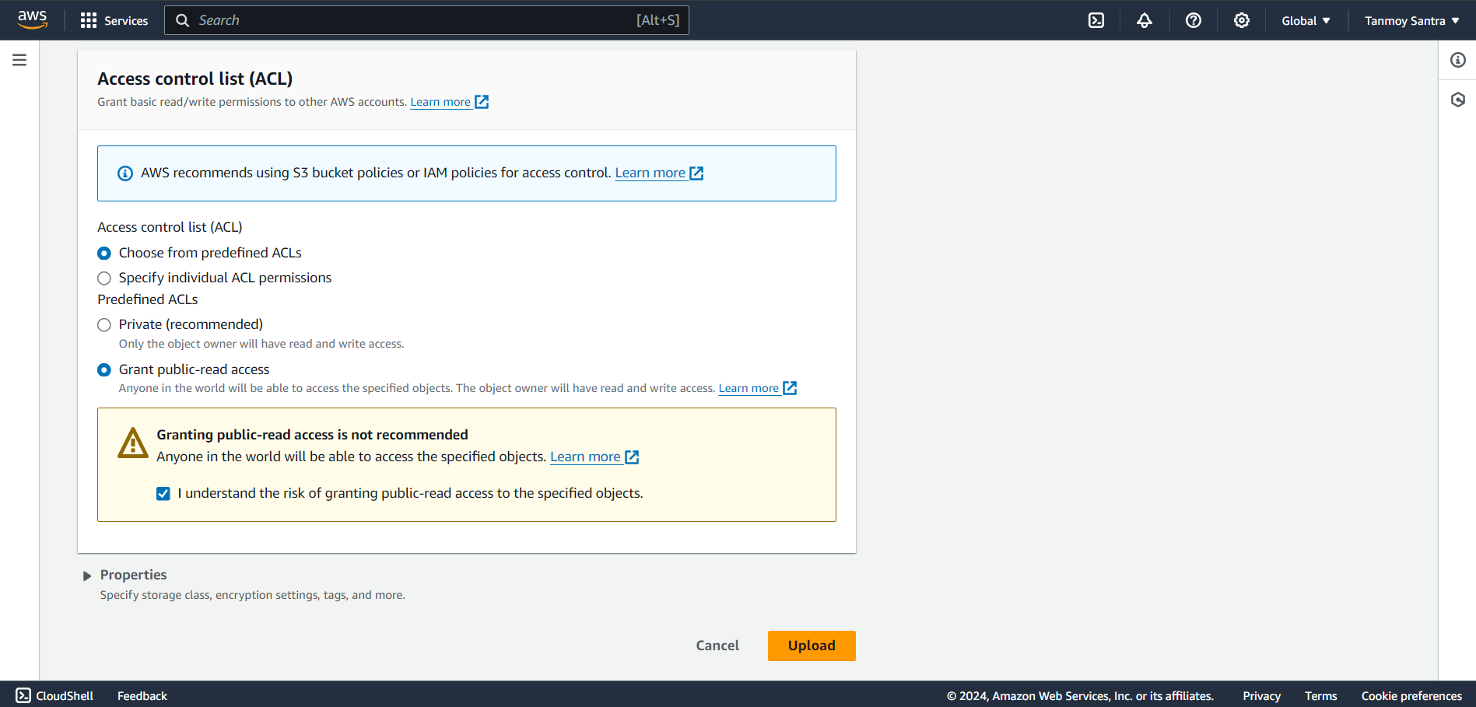

STEP 11- The file has been uploaded successfully.

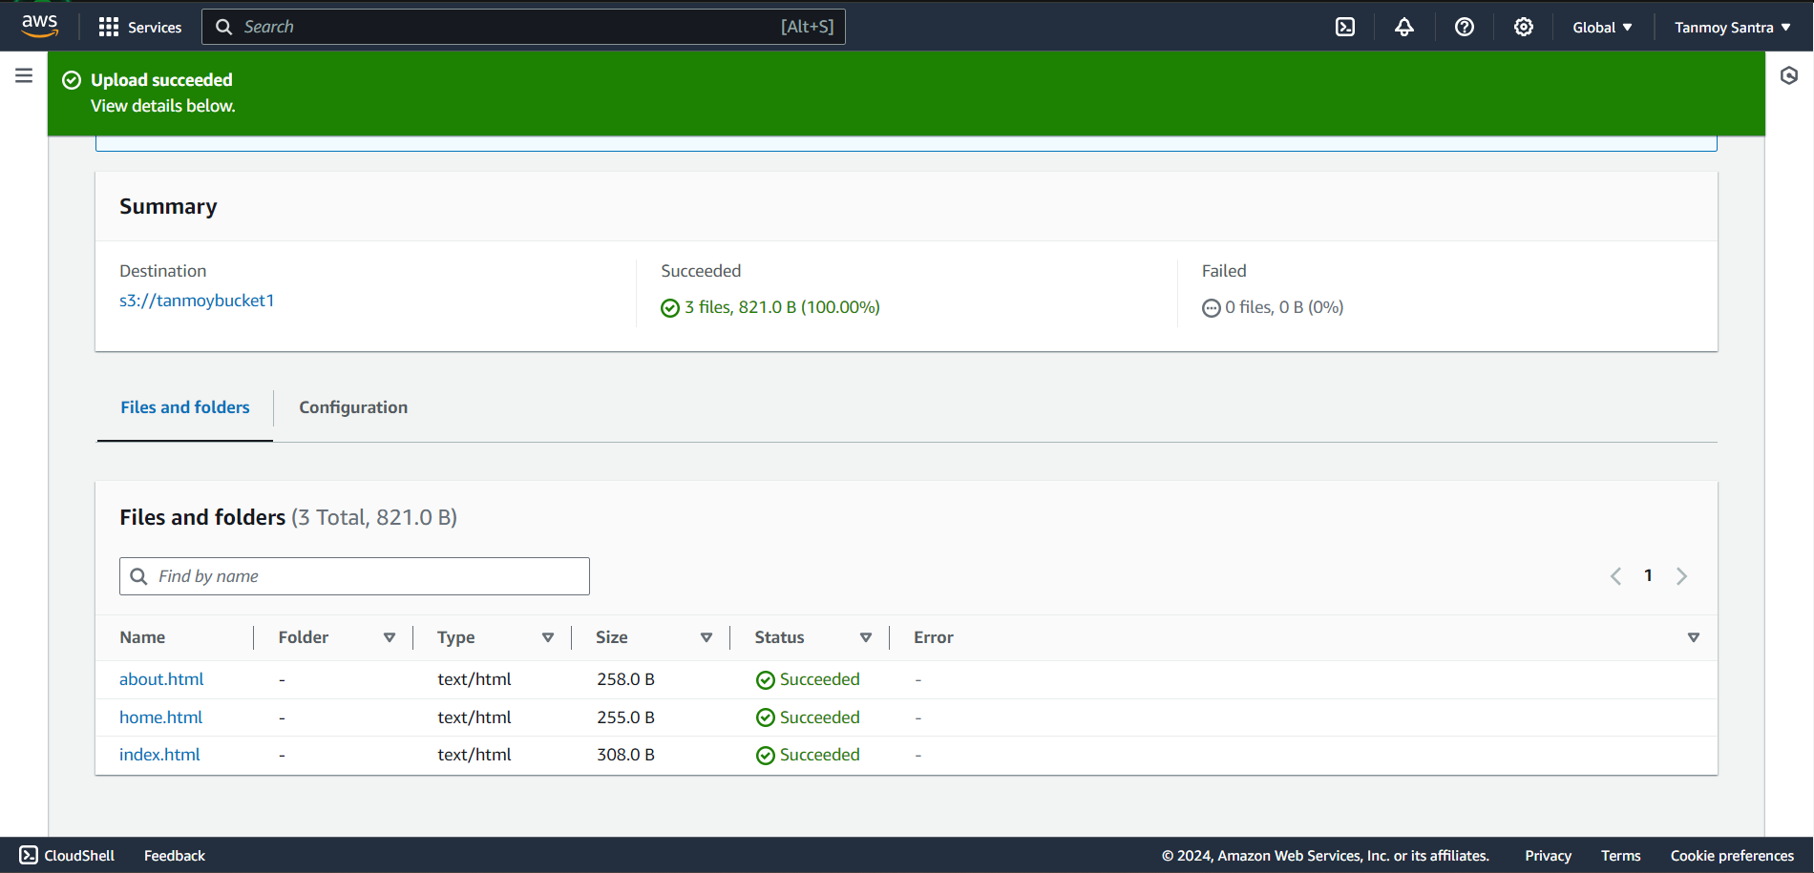

STEP 12- From the bucket go to the Properties.

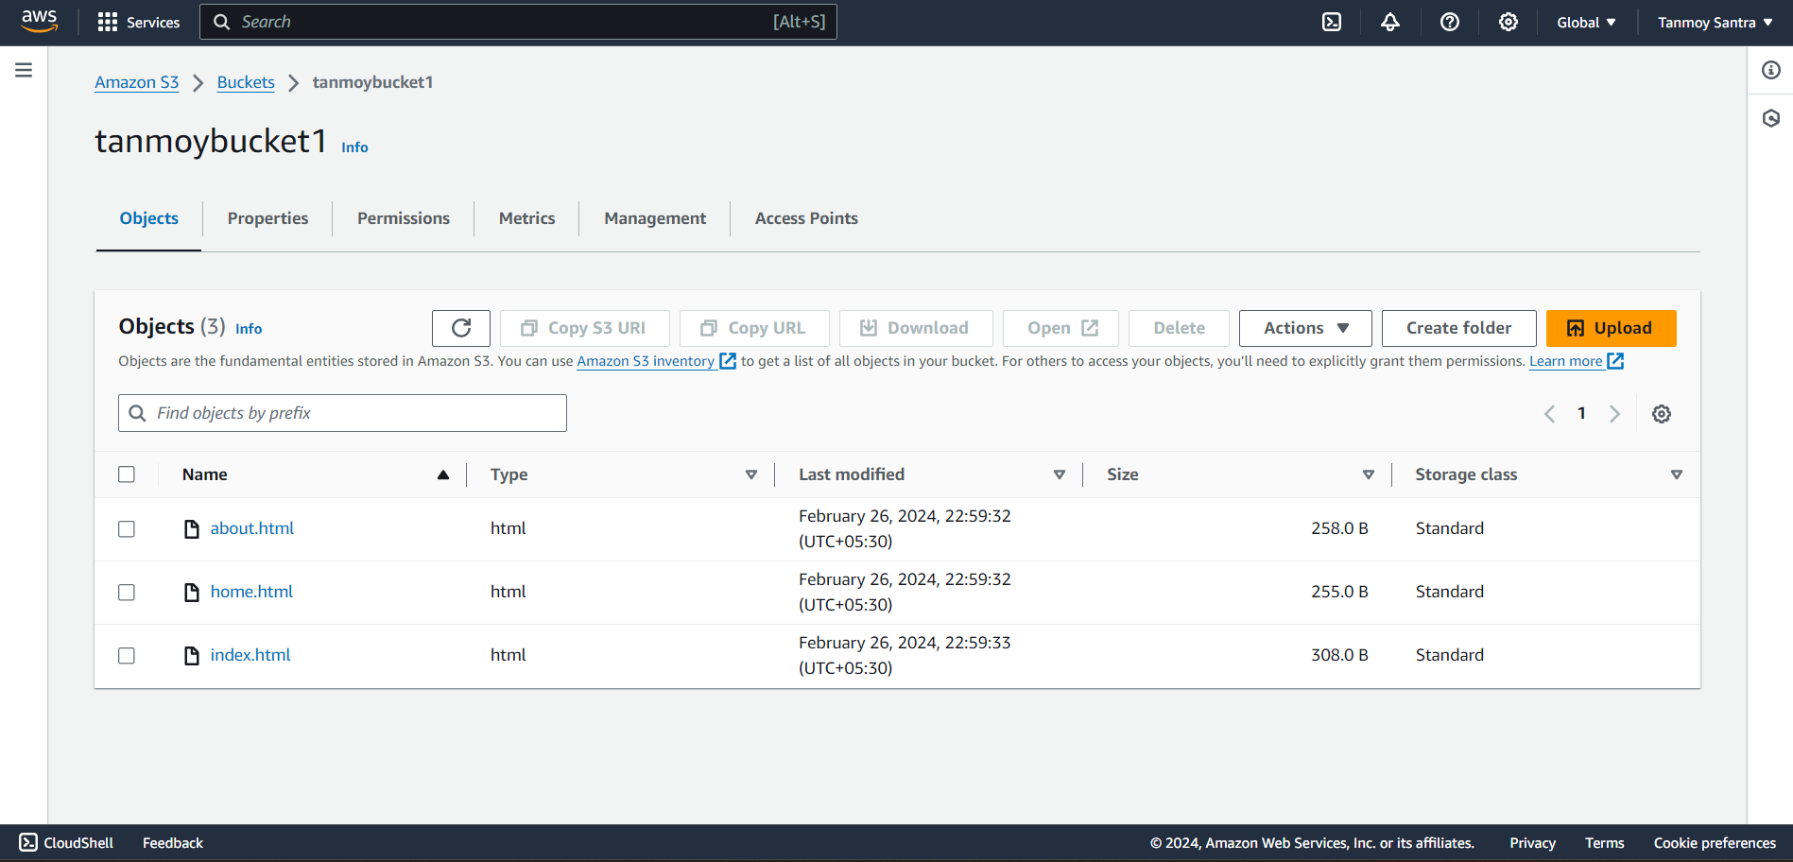

STEP 13- In Static Website Hosting, click on Edit .

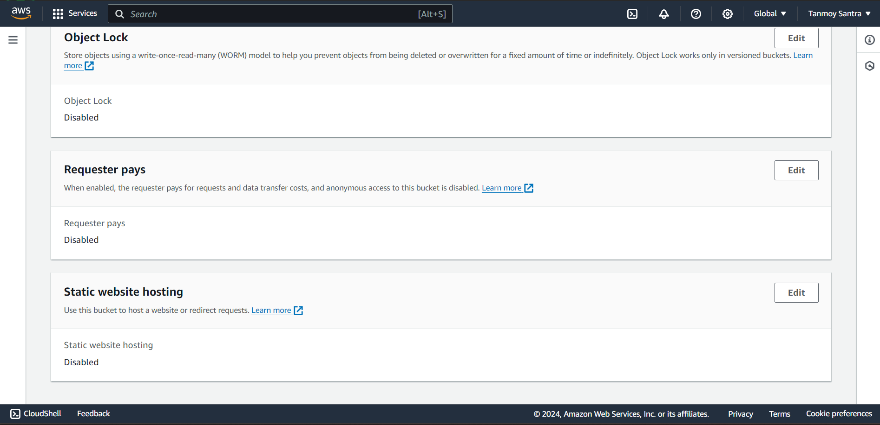

STEP 14- Select Enable. Give the name of the index file “index.html”.

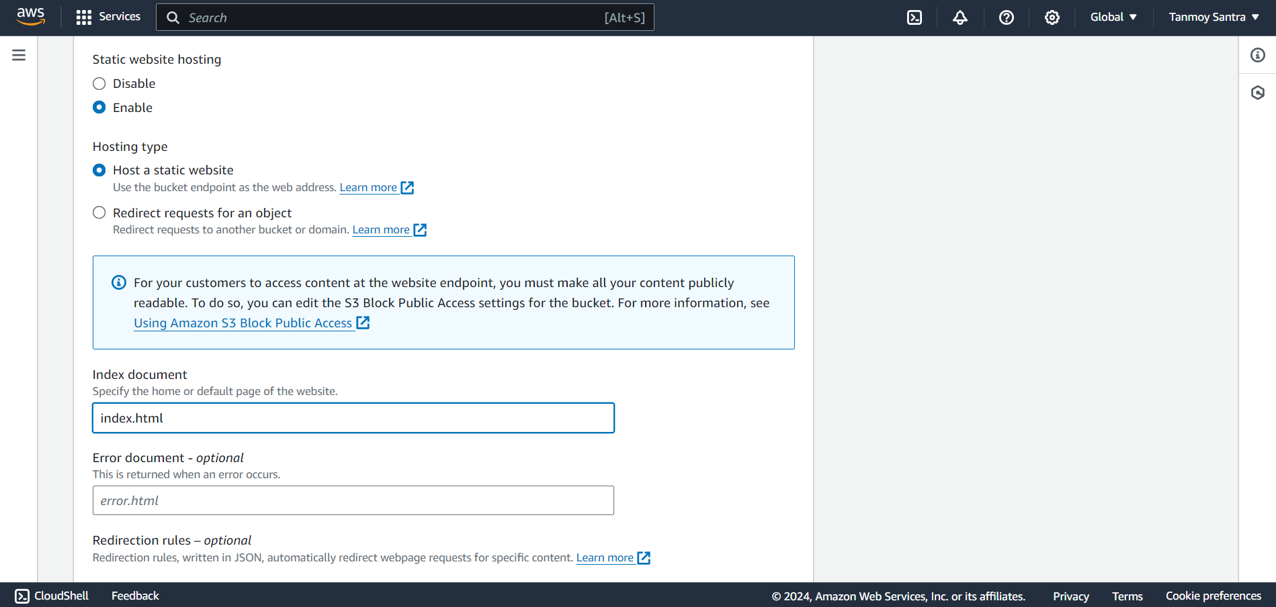

STEP 15- Click on “Save Changes”.

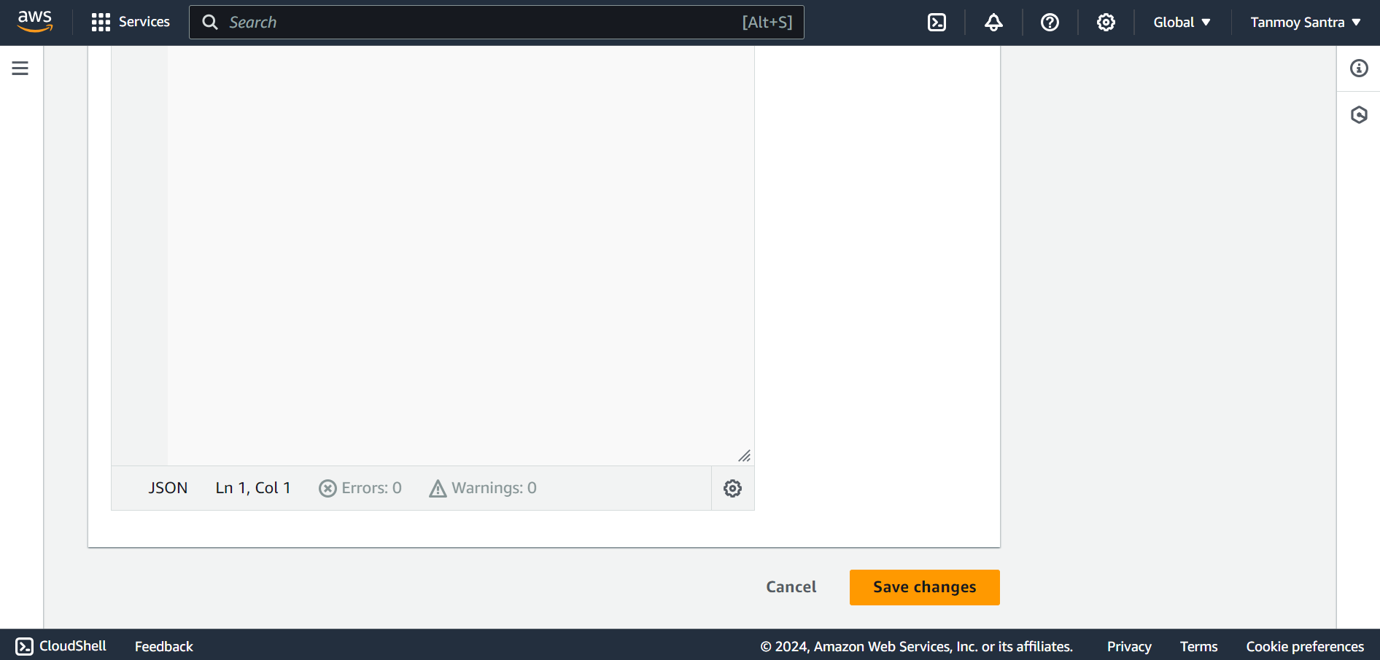

STEP 16- From Static Website Hosting copy the url.

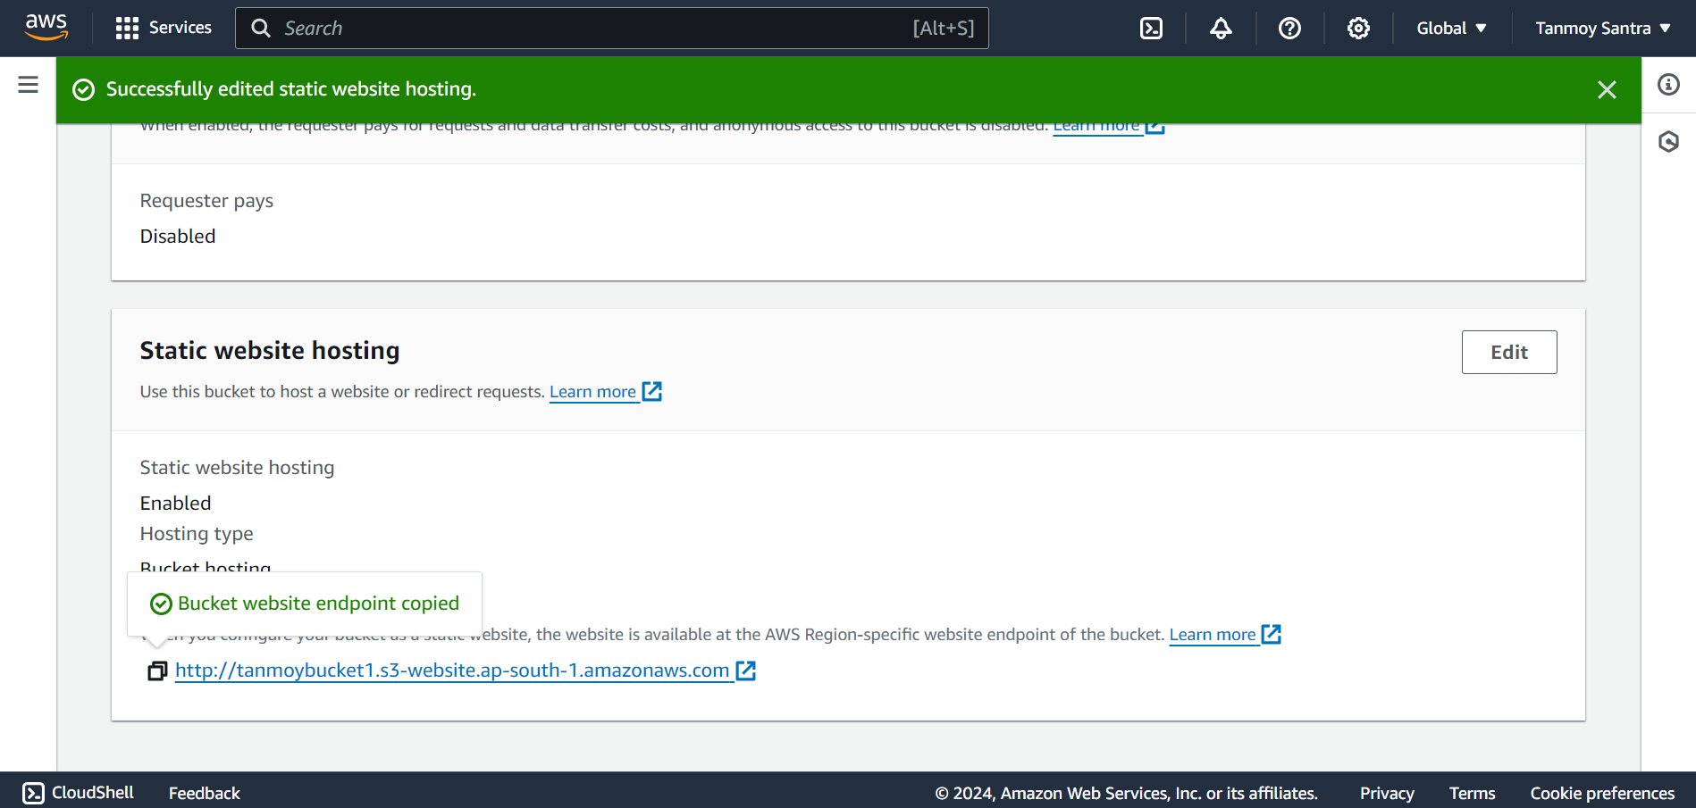

STEP 17- Open a new window and paste the url.

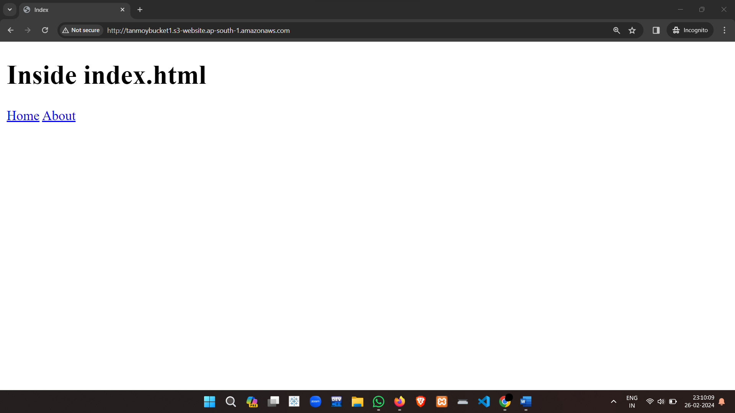

By Click on ‘Home’ go to the Home.html page.

